Evonik donates $40,000 to the University of South Alabama
- Funds for training equipment aid school’s new Process Technology (PTEC) program
- Support of education for critical industrial workforce

Mobile, AL, May 26, 2022 – Evonik, one of the world's leading specialty chemicals companies, has donated $40,000 towards a skills trainer for students enrolled in the Process Technology (PTEC) program at the University of South Alabama. A skills trainer or “training skid” is a realistic industrial process system that allows students to practice common scenarios they might encounter during work as a chemical process operator.

Process Technology (PTEC) is the study and application of scientific principles for the operation and maintenance of complex chemical plants. PTEC programs prepare students for employment as process, research, or laboratory technicians.

The donation underscores Evonik’s ongoing commitment to supporting education in the fields of Science, Technology, Engineering, and Math (STEM). “We are excited to support efforts to develop a diverse Process Technology talent pool. These students will strengthen the local workforce and our community,” remarked Chris Mitchell, Director of Energy and Utilities at Evonik in Mobile.

Evonik, the University of South Alabama, and other local chemical industry partners established an advanced education program for potential chemical operators. The school’s process technology program officially started in January 2022. Classroom instruction and simulation training are well underway.

“We are hopeful to have an actual process equipment hands-on training skid unit installed on campus for classes this fall,” said Steve Duff, Director of the Talent Development Program within the School of Computing at the University of South Alabama. The unit will allow students to learn and demonstrate hands-on plant operator skills in a safe and environmentally friendly atmosphere. “Thanks to Evonik and their donation, the University of South Alabama is now closer to having this hope become a reality,” said Duff.

Evonik employs approximately 850 people at its site in Mobile, Alabama.

For additional information about Evonik in North America, please visit our website: http://corporate.evonik.us/region/north_america.

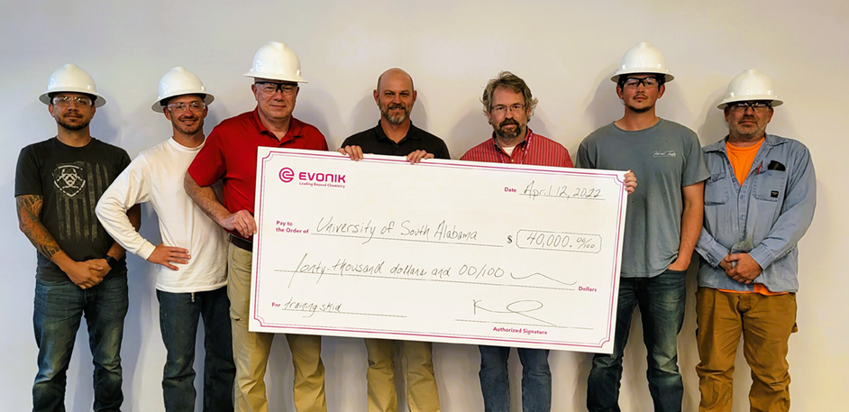
Photo caption: Evonik donated $40,000 for the PTEC program at the University of South Alabama.
Pictured are PTEC students and representatives of Evonik and the school. Holding the check (left to right): Steve Duff (University of South Alabama), Chris Mitchell, and Kel Boisvert (both Evonik).

Press contact:
Norbert Kuls
Communications Manager North America
Evonik Corporation
Phone: +1 973 437-0542
norbert.kuls@evonik.com

Regional press contact:
Kelly Miears
Communications Specialist
Evonik Corporation
Phone: +1 251 443-2390
kelly.miears@evonik.com

Company information
Evonik is one of the world leaders in specialty chemicals. The company is active in more than 100 countries around the world and generated sales of €15 billion and an operating profit (adjusted EBITDA) of €2.38 billion in 2021. Evonik goes far beyond chemistry to create innovative, profitable and sustainable solutions for customers. About 33,000 employees work together for a common purpose: We want to improve life today and tomorrow.

Disclaimer
In so far as forecasts or expectations are expressed in this press release or where our statements concern the future, these forecasts, expectations or statements may involve known or unknown risks and uncertainties. Actual results or developments may vary, depending on changes in the operating environment. Neither Evonik Industries AG nor its group companies assume an obligation to update the forecasts, expectations or statements contained in this release.

Evonik Industries AG
Rellinghauser Straße 1-11
45128 Essen
Germany
Phone +49 201 177-01
www.evonik.com
Supervisory Board: Bernd Tönjes, Chairman
Executive Board: Christian Kullmann, Chairman, Dr. Harald Schwager, Deputy Chairman, Thomas Wessel, Ute Wolf
Registered Office is Essen
Register Court Essen Local Court
Commercial Registry B 19474

